1. How many trips have been recorded total during the chosen period?
   1. 843,416

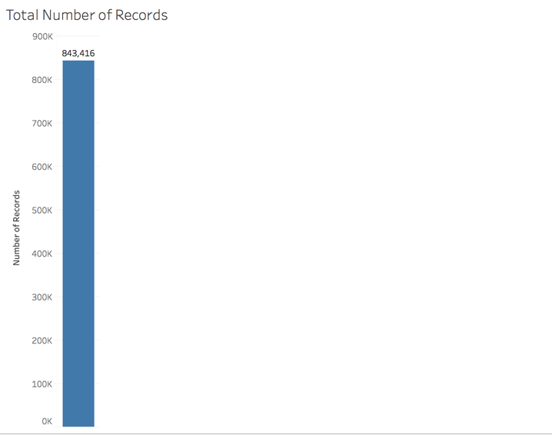

1. By what percentage has total ridership grown?
2. How has the proportion of short-term customers and annual subscribers changed?
3. What are the peak hours in which bikes are used during summer months?
   1. 5:00pm

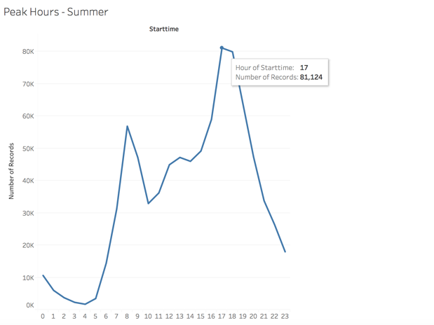

1. What are the peak hours in which bikes are used during winter months?
2. Today, what are the top 10 stations in the city for starting a journey? (Based on data, why do you hypothesize these are the top locations?)
   1. Below are the top 10 locations. The most riders were born in the early 80’s these locations are in densely populated areas. 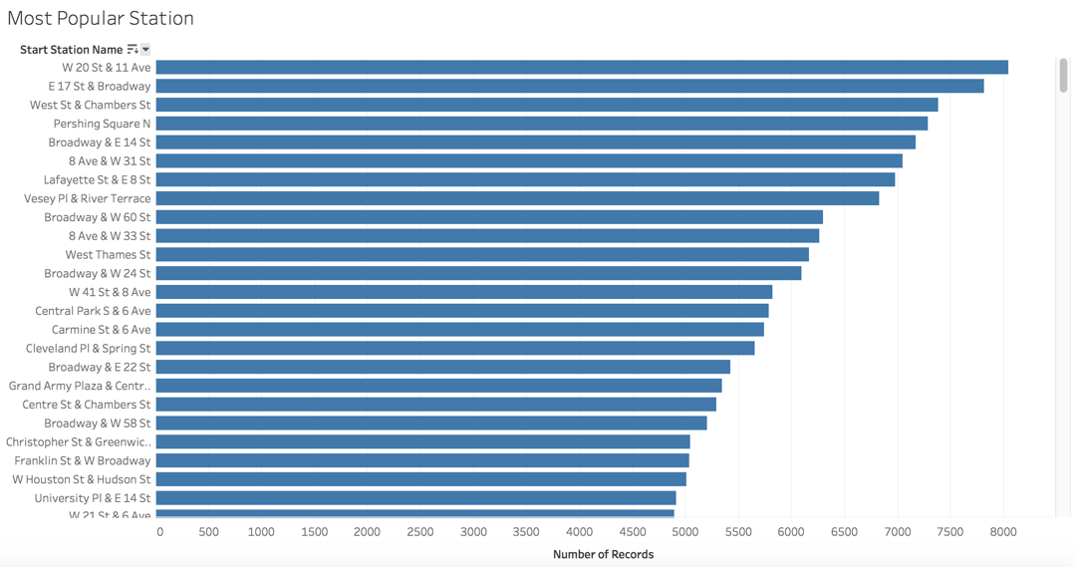
3. Today, what are the top 10 stations in the city for ending a journey? (Based on data, why?)
4. Today, what are the bottom 10 stations in the city for starting a journey? (Based on data, why?)
5. Today, what are the bottom 10 stations in the city for ending a journey (Based on data, why?)
6. Today, what is the gender breakdown of active participants (Male v. Female)?
7. How effective has gender outreach been in increasing female ridership over the timespan?
8. How does the average trip duration change by age?
9. What is the average distance in miles that a bike is ridden?
10. Which bikes (by ID) are most likely due for repair or inspection in the timespan?
    1. Below is a graph showing the must used bikes by ID, which based on use are most likely due for inspection and maintenance.

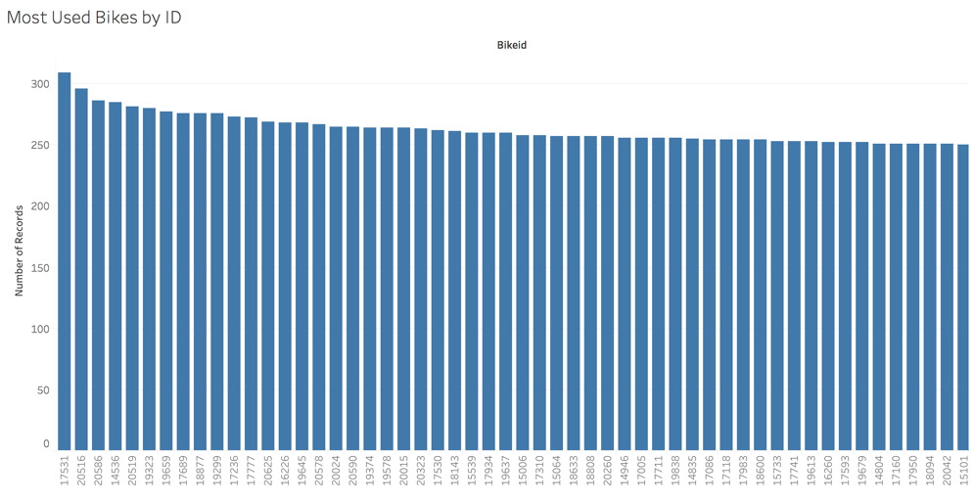

1. How variable is the utilization by bike ID?